**NAME: Tanmay Karmarkar ROLL NO: 21143**

**CLASS: S.E. COMP SUBJECT: DEL**

**EXPT. NO. 9 DATE: 16/12/2021**

**TITLE:** REALISATION OF MOD-N COUNTER USING DECADE COUNTER IC-7490

**OBJECTIVES:**

1. To verify IC-7490

2. To design and implement MOD-6

3. To design and implement MOD-96

**APPARATUS:**

Digital trainer kit, IC 7490, Patch cord, +5V Power supply.

**THEORY:**

IC 7490 is a TTL MSI decade counter. It contains four master slave flip flops and a few logic gates to provide a divide by two counter and a 3 stage binary counter which provides a divide by 5 counter.

IC 7490 is a 14 pin IC.

**Pin Diagram:**

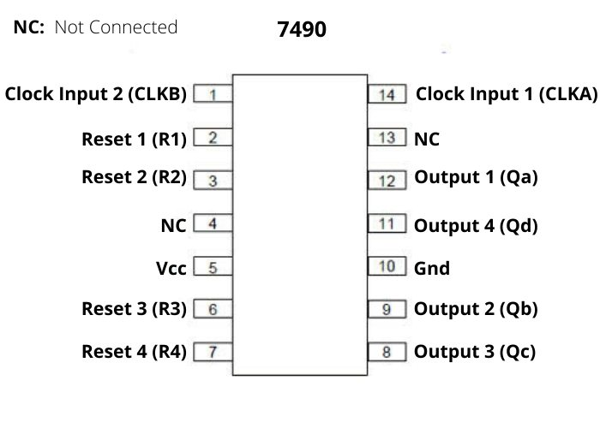

**Simplified Internal Diagram of IC 7490:**

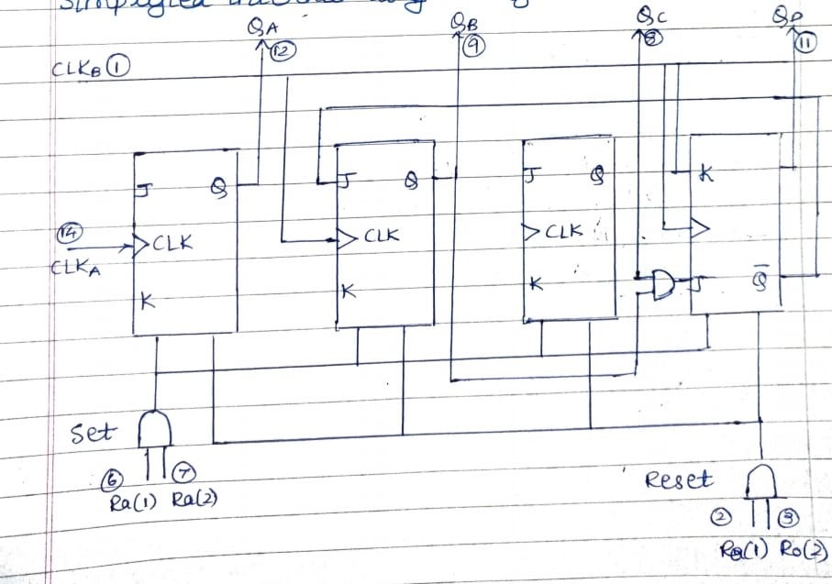

* If both the reset input R0(1) and R0(2) are at logic 1 then all the flip flops will be reset and the output is given by-

QdQcQbQa=0000.

* If both the reset input Ra(1) and Ra(2) are at logic 1 then the counter output is set to decimal 9.

QdQcQbQa=1001.

* If any one pin of R0(1) and R0(2) and one of Ra(1) and Ra(2) are at low, then the counter will be in counting mode.

**Reset/Count Truth Table:**

|  |  |  |  |  |  |  |  |
| --- | --- | --- | --- | --- | --- | --- | --- |
| **Reset Inputs** | | | | **Output** | | | |
| **R0(1)** | **R0(2)** | **Ra(1)** | **Ra(2)** | **Qd** | **Qc** | **Qb** | **Qa** |
| **1** | **1** | **0** | **X** | **0** | **0** | **0** | **0** |
| **1** | **1** | **X** | **0** | **0** | **0** | **0** | **0** |
| **X** | **X** | **1** | **1** | **1** | **0** | **0** | **1** |
| **X** | **0** | **X** | **0** | **COUNTER** | | | |
| **0** | **X** | **0** | **X** | **COUNTER** | | | |
| **0** | **X** | **X** | **0** | **COUNTER** | | | |
| **X** | **0** | **0** | **X** | **COUNTER** | | | |

**Logic Diagram:**

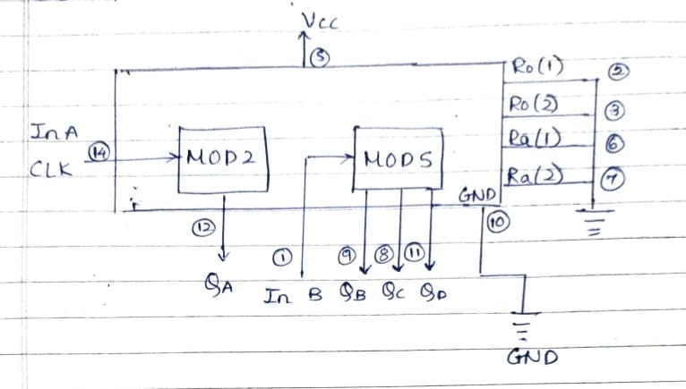

**Truth Table:**

|  |  |  |  |  |
| --- | --- | --- | --- | --- |
| **Count** | **Qd** | **Qc** | **Qb** | **Qa** |
| **0(start)** | **0** | **0** | **0** | **0** |
| **1** | **0** | **0** | **0** | **1** |
| **2** | **0** | **0** | **1** | **0** |
| **3** | **0** | **0** | **1** | **1** |
| **4** | **0** | **1** | **0** | **0** |
| **5** | **0** | **1** | **0** | **1** |
| **6** | **0** | **1** | **1** | **0** |
| **7** | **0** | **1** | **1** | **1** |
| **8** | **1** | **0** | **0** | **0** |
| **9** | **1** | **0** | **0** | **1** |
| **10(new cycle)** | **0** | **0** | **0** | **0** |

**Design and implementation of MOD-6 Counter:**

Mod-6 counter counts through 6 states.

**Truth Table:**

|  |  |  |  |  |
| --- | --- | --- | --- | --- |
| **Qd** | **Qc** | **Qb** | **Qa** | **Y** |
| **0** | **0** | **0** | **0** | **0** |
| **0** | **0** | **0** | **1** | **0** |
| **0** | **0** | **1** | **0** | **0** |
| **0** | **0** | **1** | **1** | **0** |
| **0** | **1** | **0** | **0** | **0** |
| **0** | **1** | **0** | **1** | **0** |
| **0** | **1** | **1** | **0** | **1(invalid)** |
| **0** | **1** | **1** | **1** | **1(invalid)** |
| **1** | **0** | **0** | **0** | **1(invalid)** |
| **1** | **0** | **0** | **1** | **1(invalid)** |

**K-Map for Reset Logic:**

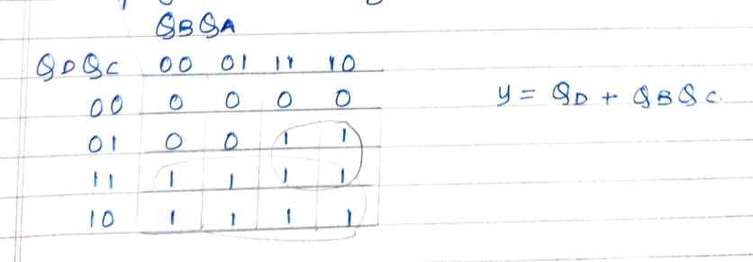

**Logic Diagram:**

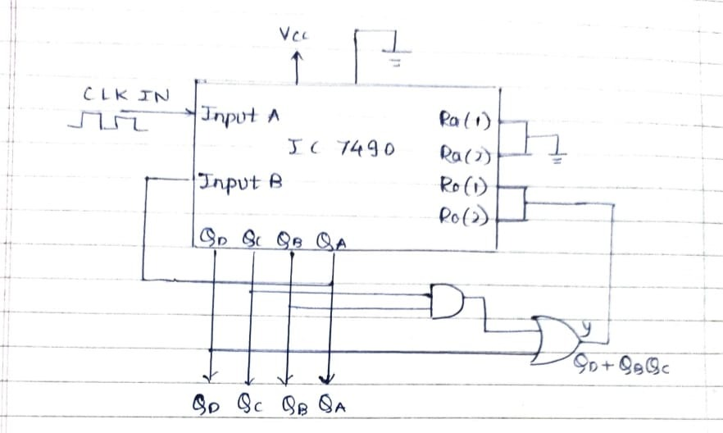

**State Diagram:**

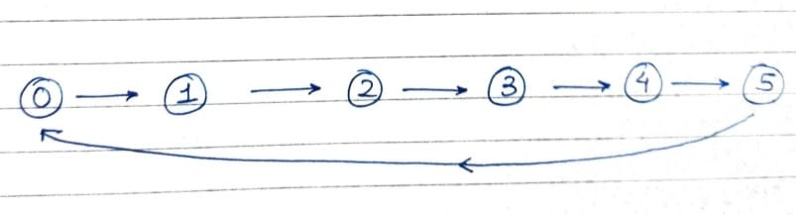

From all the invalid states (6,7,8,9) and from 6. The counter should reset.

**Design and implementation of MOD-96 counter:**

We have to implement MOD-96 counter. So upto MOD-100 two IC7490s will be sufficient, i.e. we have to use two decade counters.

A MOD-96 counter counts through 96 states through 0 to 95. Therefore, the counter should reset as sson as the count becomes 96.

So in order to reset the counter at 96, connect the Q outputs, which are equal to 1 in the count of 96 to an AND gate and then connect the AND output to Ro(1) and Ro(2) i.e., reset inputs of both the ICs.

**Reset Logic:**

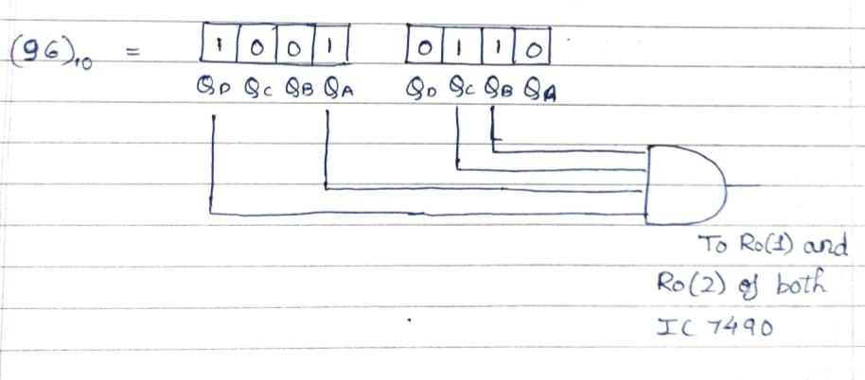

**Logic Diagram:**

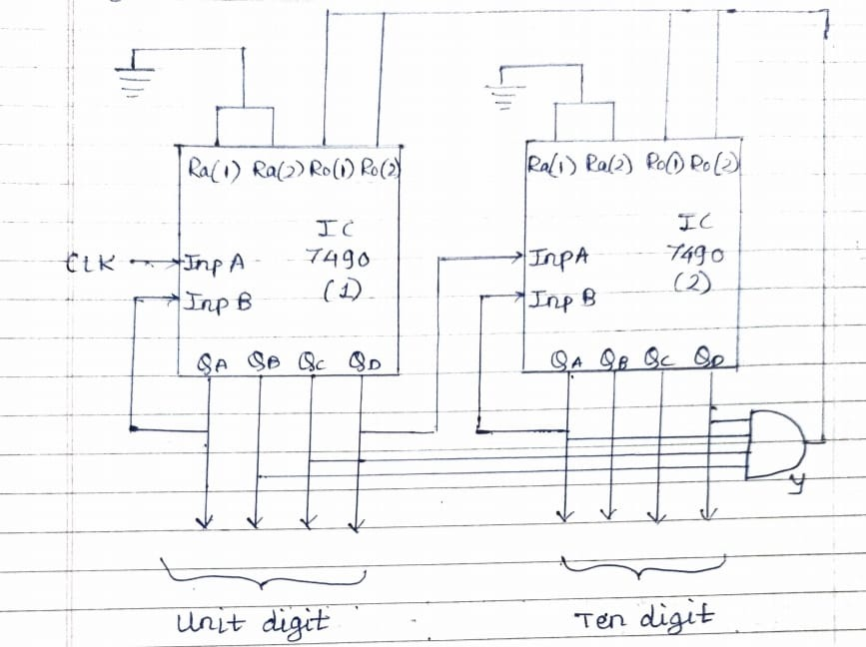

**Applications of IC 7490 (Decade counter):**

1. It is used in digital counter circuits.

2. It is used in digital timers and clocks.

3. It is used in automatic controller circuits.

**CONCLUSION:**

Hence, we have verified IC 7490 and also have successfully designed and implemented MOD-6 counter and MOD-96 counter using IC 7490.

**REFFRENCE:**

1. **R.P.Jain “Modern Digital Electronics” TMH 4th Edition**

1. **D.Leach,Malvino,Saha,”Digital Principles and Applications”,TMH**

Subject teacher Sign with Date Remark